- General description
MP3_Module is a self-design module based on the chip of JQ6500-24SS MP3 launched by the JQ Electronic Company and it supports FAT16, FAT32 file system SD card，supports SPI Flash computer directly update. Only via simple serial port command, the music playing could be controlled, operation easy, performance stable. At the same time, the board with both PH and SP, facilitates your selection and use.
- Features
- Supports sampling rates (KHz):8/ 11.025 /12 /16 /22.05 /24 /32 /44.1/48
- 24 bit DAC output, dynamic range supports 90dB, SNR supports 85dB
- Fully supports FAT16、FAT32 File System， maximum supports 32G TF card,32G U disk , 64M bytes of NORFLASH
- Variety of control modes, serial mode, AD key control mode
- Broadcast language spots feature, you can pause the background music being played
- 30 levels volume adjustable, 10 levels EQ adjustable.
- Plug spi flash, and connecting to PC can display spi flash Letter to update contents.
- Controlled by the microcontroller serial port to play the specified music
- In Key mode, you can select the play mode: pulse can be repeated, the pulse can not be repeated, maintaining the level of non-recyclable, maintaining the level of recyclable.
- Audio data is sorted by folder, and supports up to 100 folders, every folder assigned to 1000 songs
- Size 50.00mm×47.15mm

- Applications
- Car navigation voice broadcast

- Highway transport inspection, toll station voice prompts
- Train station, bus station security check voice prompts
- Electricity, communications, financial business hall voice prompts
- The voice prompts for verification of vehicles into and out of the channel
- Public security frontier channel voice prompts
- Multi-channel voice alarm or equipment operating guide voice
- Electric sightseeing cars safe driving voice notices
- Electromechanical equipment failure alarm
- Electronic characteristics
PARAMETER | MIN | TYP | MAX | UNIT
Power Supply Voltage | - | 5/3.3 | - | V
- Pining information
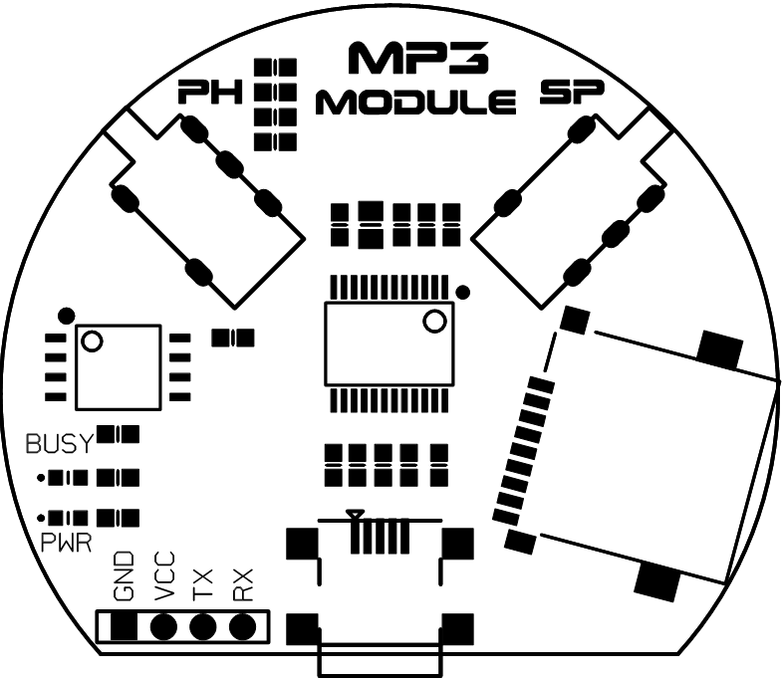

Types | Symbols | Description
MP3 MODULE  PIN | GND | POWER Ground
MP3 MODULE  PIN | V | POWER Supply 5V
MP3 MODULE  PIN | TX | Serial Interface
MP3 MODULE  PIN | RX | Serial Interface

- Interface description
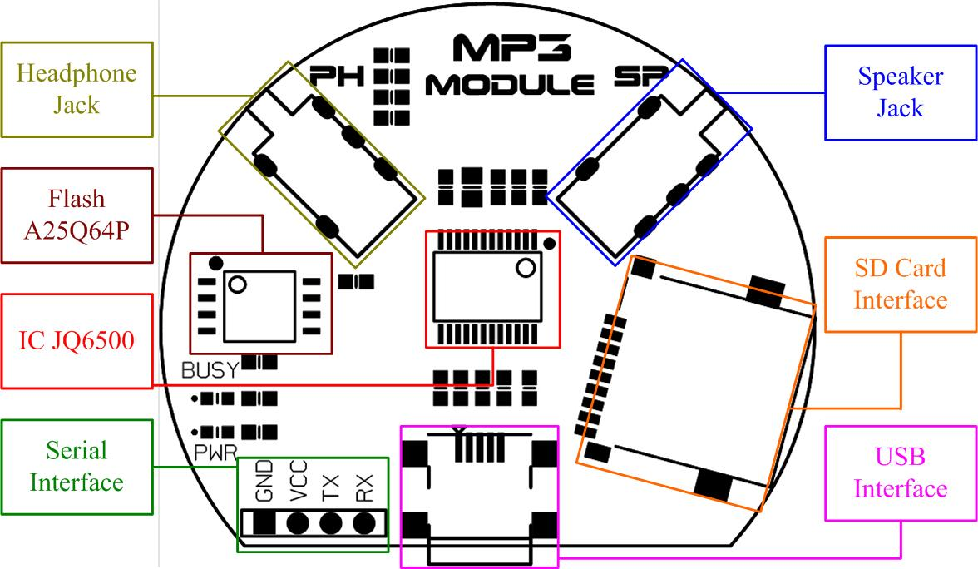

- Dimension outline
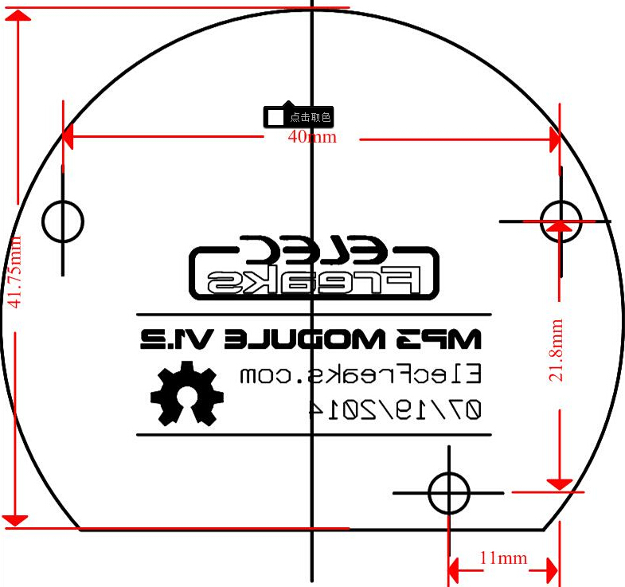

- Revision history

REVISION | DESCRIPTION | RELEASE DATE
V1.0 | Initial version | 07/28/2014

- Contact information
If you need more information, please refer to http://www.elecfreaks.com

- Communications Directive
1. Send commands directly no need return parameters
Detailed CMD (command) | Corresponding Function | Parameters (16 bits) and the Corresponding Instruction Format
0x01 | next | 【7E 02 01 EF】
0x02 | pre | 【7E 02 02 EF】
0x03 | assigned song | 0-65535、SPI(0-200)  【7E 04 03 00 01 EF】  Indicates the playback of the first paragraph of music.  The red font is the number of paragraphs that they can change.
0x04 | volume+ | 【7E 02 04 EF】
0x05 | volume - | 【7E 02 05 EF】
0x06 | assigned volume | 0-30【7E 03 06 15 EF】  The red font is the volume range from 00 to 1E.
0x07 | assigned EQ(0/1/2/3/4/5) | Normal/Pop/Rock/Jazz/Classic/Base  【7E 03 07 01 EF】  The red font can be changed from 00 to 05.
0x09 | assigned devices(0/1/2/3/4) | U/TF/AUX/SLEEP/FLASH  【7E 03 09 01 EF】  The red font can be changed from 00 to 05.
0x0A | enter sleep mode - low power consumption | Pause  【7E 02 0A EF】
0x0C | chip reset | 【7E 02 0C EF】
0x0D | play | 【7E 02 0D EF】
0x0E | pause | 【7E 02 0E EF】
0x0F | folders switching | 1 the next folder; o the previous folder  【7E 03 0F 00 EF】The red fond can be described as 00 01.
0x10 | preserve
0x11 | loop | 0 1 2 3 4(ALL FOL ONE RAM ONE_STOP)  【7E 03 11 00 EF】The red font is 0001 corresponding mode: 00 for All Cycle, 01 for Single Cycle. Eg: To repeat the second song, first send 7E 03 11 01 EF and then sent 7E 04 03 00 02 EF.
0x12 | specified folder file playback | 01 01  The former 01 refers to the folder while the latter refers to the file. Note 1:  【7E 04 12 01 01 EF】  play the file 01 in the folder 01

For example, for next, send: 7E 02 01 EF
For previous, send: 7E 02 02 EF
For play, send: 7E 02 0D EF

- Parameter Query
Detailed CMD (command) | Corresponding Function | Description and Command Format
0x40 | Return error, request resend
0x42 | Check the current status | Three states: Play Stop Pause  【7E 02 42 EF】
0x43 | Inquire the current volume | 【7E 02 43 EF】
0x44 | Inquire the current EQ | The return value corresponds to 012345（Normal/Pop/Rock/Jazz/Classic/Base）  【7E 02 44 EF】
0x45 | Inquire the current play mode | The return value corresponds to 0 1 2 3 4(ALL FOL ONE RAM ONE_STOP)  【7E 02 45 EF】
0x46 | Inquire the current software version | 【7E 02 46 EF】
0x47 | Check the total number of files of TF card | 【7E 02 47 EF】
0x48 | Inquire the total number of UDISK files | 【7E 02 48 EF】
0x49 | Inquire the total number of FLASH files | 【7E 02 49 EF】
0x4B | Inquire the current track of TF card | 【7E 02 4B EF】
0x4C | Inquire the current track of UDISK | 【7E 02 4C EF】
0x4D | Inquire the current track of FLASH | 【7E 02 4D EF】
0x50 | Inquire the current play time | 【7E 02 50 EF】
0x51 | Inquire the total play time of the current track | 【7E 02 51 EF】
0x52 | Inquire the name of the playing song | The return value is the name of the song(SPIflsh not supported)  【7E 02 52 EF】
0x53 | Inquire the total number of the current folders | 【7E 02 53 EF】

Example: To read the volume, sent [7E 02 43 EF], it’ll directly return to volume (16 bits)

ADKEY resistance function: 0R PLAY 3.3K for Next, V + 6.2K for Pre, V-9.1K for mode switching.
Note 1: The folders inside USB and TF card must be named 01 02...99; the files inside the folders must be named 001 002 003....

- Instructions on Voice Update
Connect the MINI USB of the module to the computer. Open “My Computer”, double-click the “CD Drive”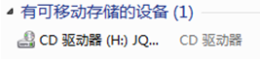, and you will see an update content of PC software, as shown below:
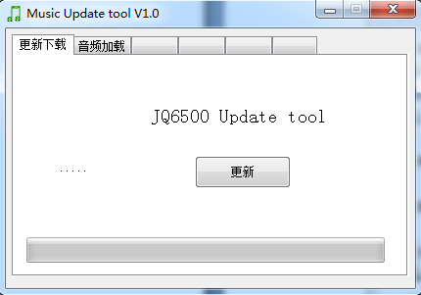

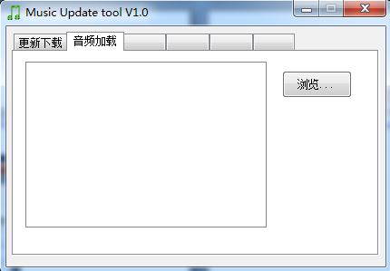
Select "Audio loading" - Click "Browse".

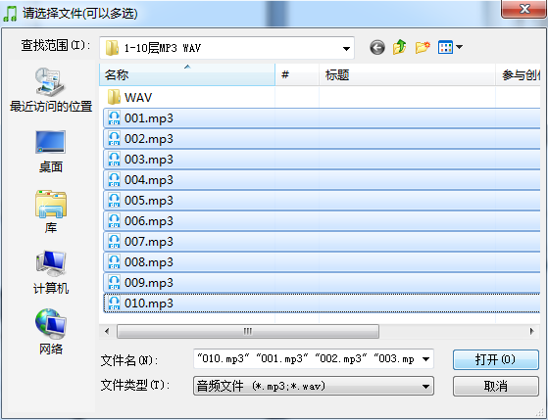
Choose the audio, click the "Open".

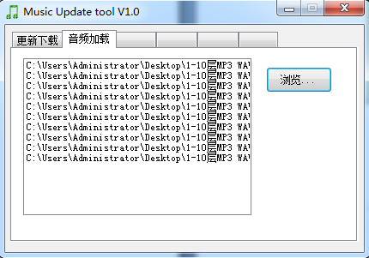
The audio is added to the PC software.

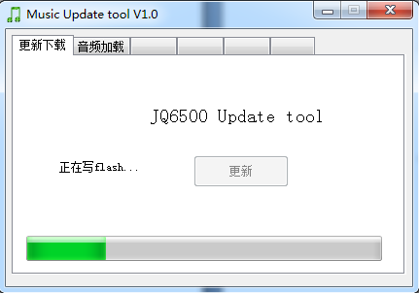
Select "update download" tab, click update;
Audio writing is shown in picture.

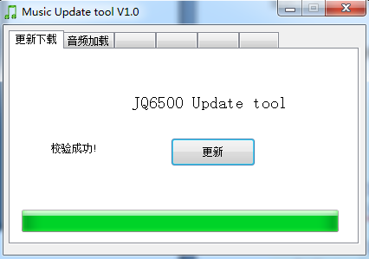
The picture means that the voice has been downloaded to the spi flash in the module.

