MP3_Module User Guide

I. MP3 Module Introduction
MP3 Module is one of our self-developed modules inspired from JQ6500-24SS MP3 chipset of Jiaqiang Electronics. It supports SD cards for FAT16, FAT32 file systems and SPI Flash updates via PC. Via some very simple serial commands to control music playback, it owns the characteristics of easy operation and stable performance. Additionally, with an external headphone (PH) and an external speaker (SP), the MP3 Module provides more interfaces and utility.
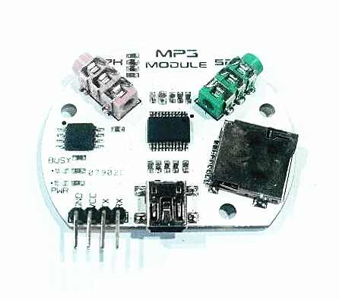

II. Hardware and Software Preparation
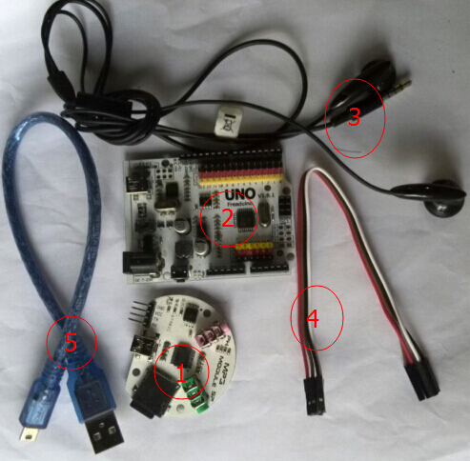

Hardware：
- MP3 Module
- Arduino mainboard
- A pair of headset or speaker
- Jumper wire
- USB cable

Software：
- MP3_Module_TEST_CODE
- Arduino IDE(1.0.5)

III. Flash Testing

      - Connect the MP3 module to computer via USB.
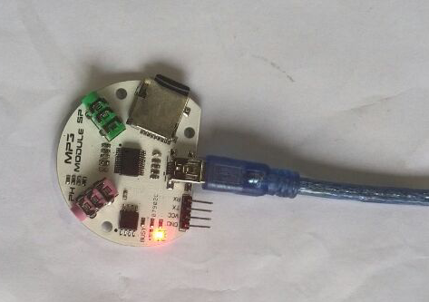

      - Open “My Computer”, you will see a new CD driver named “JQ6500” has been added. If you want to use Flash to play music, see Flash part in JQ6500 user guide.
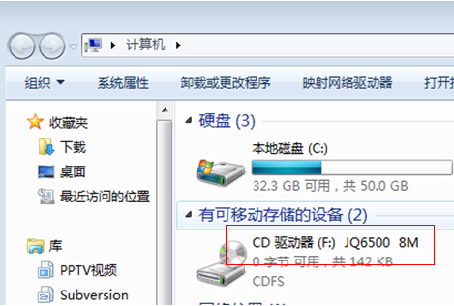

IV. SD Card Music Playback Testing
Step 1. Connect.
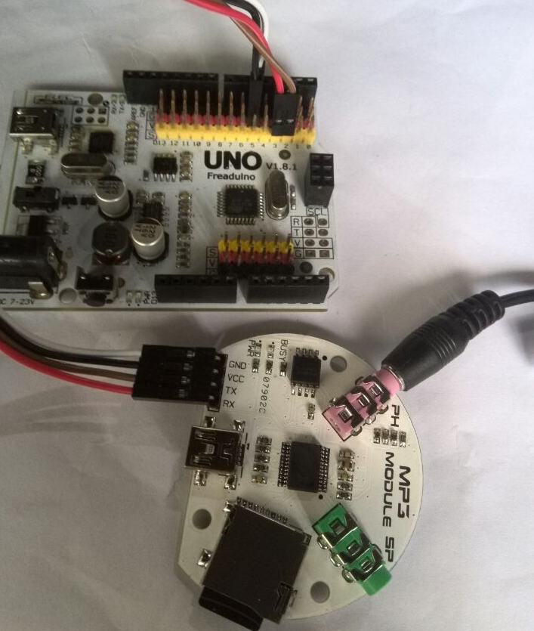

MP3 Module and Arduino UNO Connecting Chart
MFRC Module | Arduino UNO
GND | GND
+5V | +5V
TX | D2
RX | D3

Step 2. Compile and run the Arduino (1.0.5) IDE code

            - Download the zip file 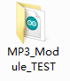from ElecFreaks official web. After unzipping the file, open it, enter the interface as shown below:
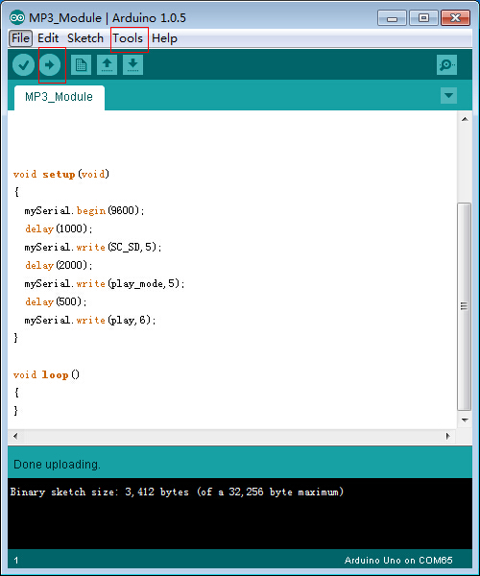

            - Click at “Tools”, “Board” and “Arduino UNO” in turns. Click again at “Tools”, followed by “Serial”, “COMX”, finally , download the codes into UNO.

            - After your successful download of the codes, plug the headset into the headphone jack labeled “PH” and press reset on UNO. If you can hear the music playing, that means the module is ok. (When you play music, the BUSY indicator on the MP3 Module always keeps on, as shown below.)

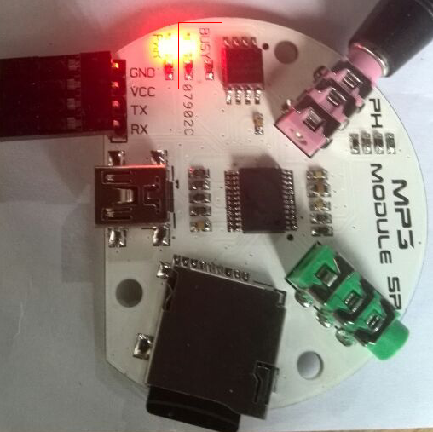

Note:
Should the music not play successfully, follow the steps to check what’s going on. First, check if your SD card file system is for FAT16 / FAT32 file system; Second, check if your SD card exceeds the maximum capacity of 32G; Third, check if you have stored music files into the SD card. If all these don’t help, you can try formatting the SD card and re-place the music files.

